**“MIMO-OFDM PRECODING WITH PHASED ARRAYS”**

**PROJECT REPORT**

Submitted for the course: Information Theory and Coding (ECE-4007)

|  |  |
| --- | --- |
| **Name** | **Registration No.** |
| Sanskar Biswal | 16BEC0403 |
| Guneet Arora | 16BEC0578 |
| Nitya Bhargava | 16BEC0792 |

By

Slot: B1+TB1

**UNDER THE GUIDANCE OF: Prof. THANIKAISELAN V**

**(SENSE SCHOOL)**



MARCH 2019

**ABSTRACT**

MIMO-OFDM systems are the norm in current wireless systems (e.g. LTE, WLAN) due to their robustness to frequency-selective channels and high data rates enabled. With ever-increasing demands on data rates supported, these systems are getting more complex and larger in configurations with increasing number of antenna elements, and resources (subcarriers) allocated.

With antenna arrays and spatial multiplexing, efficient techniques to realize the transmissions are necessary. Beamforming is one such technique that is employed to improve the signal to noise ratio (SNR) which ultimately improves the system performance, as measured here in terms of bit error rate (BER).

For a spatially multiplexed system, availability of channel information at the transmitter allows for precoding to be applied to maximize the signal energy in the direction and channel of interest. Under the assumption of a slowly varying channel, this is facilitated by sounding the channel first, wherein for a reference transmission, the receiver estimates the channel and feeds this information back to the transmitter.

After this we configure the system's data transmitter. This processing includes channel coding, bit mapping to complex symbols, splitting of the individual data stream to multiple transmit streams, precoding of the transmit streams, OFDM modulation with pilot mapping and replication for the transmit antennas employed.

Finally, for the MIMO system modelled, the displayed receive constellation of the equalized symbols offers a qualitative assessment of the reception. The actual bit error rate offers the quantitative figure by comparing the actual transmitted bits with the received decoded bits.

Mainly this illustrates an asymmetric MIMO-OFDM single-user system where the maximum number of antenna elements on transmit and receive ends can be 1024 and 32 respectively, with up to 16 independent data streams. It models a spatial channel where the array locations and antenna patterns are incorporated into the overall system design.

**BLOCK DIAGRAM**

The processing for channel sounding, data transmission and reception modeled in the example are shown in the following block diagrams.

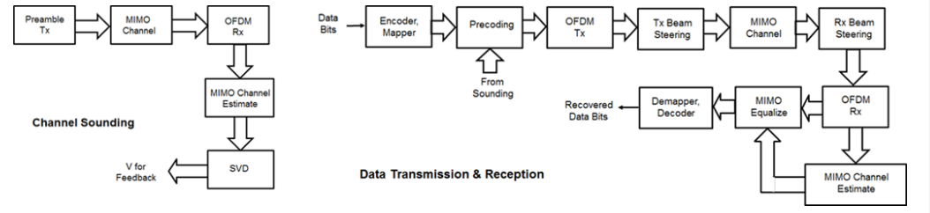

Using utilities from the Phased Array System Toolbox, the free space path loss is calculated based on the base station and mobile station positions for the spatially-aware system modeled.

**METHODOLOGY**

*CHANNEL SOUNDING:*  For the chosen system, a preamble signal is sent over all transmitting elements, and processed at the receiver accounting for the channel. The receiver elements perform pre-amplification, OFDM demodulation, frequency domain channel estimation, and calculation of the feedback weights based on channel diagonalization using singular value decomposition (SVD) per data subcarrier.

*DATA TRANSMISSION:* For precoding, the preamble signal is regenerated to enable proper channel estimation. It is prepended to the data portion to form the transmission packet which is then replicated over the transmit antennas.

*TRANSMIT BEAM STEERING*: Phased Array System Toolbox offers components appropriate for the design and simulation of phased arrays used in wireless communications systems. For the spatially aware system, the signal transmitted from the base station is steered towards the direction of the mobile, so as to focus the radiated energy in the desired direction. This is achieved by applying a phase shift to each antenna element to steer the transmission.

### *SIGNAL PROPAGATION:* This offers three options for spatial MIMO channels and a simpler static-flat MIMO channel for evaluation purposes. The WINNER II channel model is a spatially defined MIMO channel that allows you to specify the array geometry and location information. The example uses the typical urban microcell indoor scenario with very low mobile speeds. The two scattering models use a single-bounce ray tracing approximation where the number of scatters is user-specified. The models allow path loss modeling and both line-of-sight (LOS) and non-LOS propagation conditions.

### *RECEIVE BEAM STEERING:* The receiver steers the incident signals to align with the transmit end steering, per receive element. Thermal noise and receiver gain are applied. Uniform linear or rectangular arrays with isotropic responses are modeled to match the channel and transmitter arrays.The receive antenna pattern mirrors the transmission steering.

### *SIGNAL RECOVERY:* The receive antenna array passes the propagated signal to the receiver to recover the original information embedded in the signal. Similar to the transmitter, the receiver used in a MIMO-OFDM system contains many stages, including OFDM demodulator, MIMO equalizer, QAM demodulator, and channel decoder.

For the MIMO system modeled, the displayed receive constellation of the equalized symbols offers a qualitative assessment of the reception. The actual bit error rate offers the quantitative figure by comparing the actual transmitted bits with the received decoded bits.

# MATLAB CODE ALGORITHM

1. Defining System Parameters in WINNER II toolbox. Features like
   1. No.of users
   2. No.of data streams
   3. Bits per channel and sub-channel etc..
2. Determination of antenna angles and locations
3. OFDM Parameters like FFT Length, no.of carriers etc defined.
4. Channel sounding module developed for transmitter side precoding.
5. Encoding data for transmission
6. Modulation of encoded data in the OFDM paradigm
7. Precoded bits are pre-fixed to the data to enable receiver side replication for beamforming process.
8. Signal propagation channel is designed and implemented to simulate a slowly varying channel, similar to the real-time systems.
9. Receiver module comprised of data collection and OFDM demodulation.
10. Channel estimation from the prefixed channel sound
11. MIMI equalization
12. Decoding the input signal
13. Plotting of the attributed data and results.

# RESULT :

# 

# 

# 

# 

# 

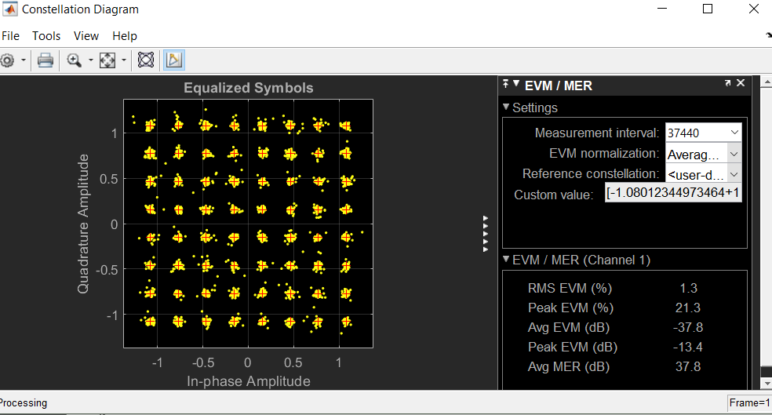

# CONCLUSION

The above highlighted the use of phased antenna arrays for a beamformed MIMO-OFDM system. It accounted for the spatial geometry and location of the arrays at the base station and mobile station for a single user system. Using channel sounding, the example illustrates how precoding is realized in current wireless systems and how steering of antenna arrays is modeled.

Within the set of configurable parameters, you can vary the number of data streams, transmit/receive antenna elements, station or array locations and geometry, channel models and their configurations to study the parameters' individual or combined effects on the system. For further exploration one can also vary just the number of transmit antennas to see the effect on the main lobe of the steered beam and the resulting system performance.

The example also made simplifying assumptions for front-end synchronization, channel feedback, user velocity and path loss models, which need to be further considered for a practical system. Individual systems also have their own procedures which must be folded in to the modeling.

# REFERENCES

* Wikipedia.com
* Mathworks.com
* Perahia, Eldad, and Robert Stacey. Next Generation Wireless LANS: 802.11n and 802.11ac. Cambridge University Press, 2013.
* IEEE® Std 802.11™-2012 IEEE Standard for Information technology - Telecommunications and information exchange between systems - Local and metropolitan area networks - Specific requirements - Part 11: Wireless LAN Medium Access Control (MAC) and Physical Layer (PHY) Specifications.